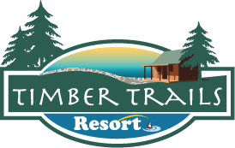
FISHING GUIDE SERVICE
On Boy Lake, MN

Guided service on Boy Lake
by Nick Plankers
Let me help you get the most out of your trip by showing you the hot spots!
Rates: 4 hours - $150; 8 hours - $300
more than 2 people, add $50/person
All equipment, rods, reels, bait & tackle are provided, but you are more than welcome to use your own equipment as well.

Pick-up location: Timber Trails Resort

For More information
Call: Timber Trails Resort @218-566-2376
or Nick @ 612-670-0024

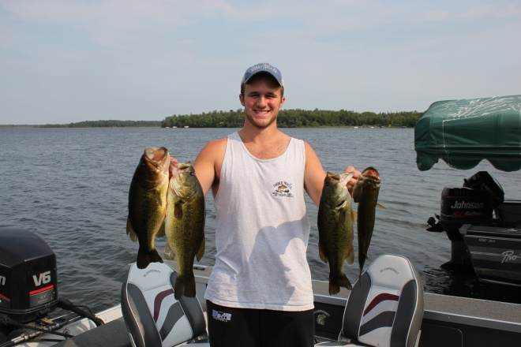

Timber Trails Resort is excited to offer this great service to our resort and lake guests with Nick Plankers.

A little about our lake:

Big Boy Lake is a 3,452-acre lake that has 26.2 miles of shoreline, a maximum depth of 45 feet and great clarity. Walleye are abundant in Big Boy Lake with the average length at 15 inches, as well as Northern Pike. Other fish species that are available for anglers to catch are Bass, Northern, Crappie, Bluegill, and even some Muskies. No aquatic invasive species or special restrictions.

The lake is a fisherman’s dream that is filled with an abundance of fishing structure like shallow bays, large points, rock humps, weed lines, deep water and shallow water. Boy Lake has direct access to Swift Lake which offers up more opportunity for great crappie fishing. There is no shortage of fishing locations.

With Nick’s experience fishing this lake since he was 4 years old, you are sure to pick up some great tips
and possibly dinner too!

